**Lesson Plan- Intro to Chemistry**

**Unit Objective:** Student will be able to differentiate between atomic number/mass, describe what an isotope is, describe why atomic masses are averages, list at least 3 trends in the periodic table, describe what periods/groups represent, and describe how at least 30 elements are applicable/relevant to their lives.

**Lesson Objective:** Student will investigate various properties of the periodic table and create a “Periodic Table” of their own that will include details about each element that they learn throughout a Unit (or up to a semester).

**Materials:** Construction paper, colored pencils/markers, glue, scissors, periodic table (one for each student), index card (optional), individual whiteboards (or chalkboards)- optional

**Procedure:** **Please note that this activity is meant to be completed as a long scale activity (anywhere from the course of a Unit to an entire semester or even school year). Students will determine trends after having learned about the chemical properties of atoms/elements. For example, they must first be taught about electron rings and valence electrons before they fully understand the distinction between a period and a group.

1. Initially give each student a standard copy of the periodic table (find attached). Group them into groups of 3. Ask each group if they can identify at least one trend (or pattern) in the periodic table. Call on groups to share their findings. Collectively your students may find several (for example: numbers increase as you go across/down or like elements are grouped together) or none. As a class record any trends discovered on a common board.
2. Throughout the next several sessions students should be learning about the various trends in the periodic table. One way you could have them figure out trends without explicitly telling them would be to have them make a table listing the Element #, Electron Ring Configuration, and the Charge of atoms 3-18. An example table is provided below with an actual after the periodic table.

|  |  |  |  |  |  |  |  |  |
| --- | --- | --- | --- | --- | --- | --- | --- | --- |
| Element # | 3 | 4 | 5 | 6 | 7 | 8 | 9 | 10 |
| Drawing of Electrons in shells |  |  |  |  |  |  |  |  |
| Amount of Electrons atom needs to gain or lose |  |  |  |  |  |  |  |  |

Students will make the same table for elements 11-18 just below the first one. After drawing the electron shells students should figure out that as they move across the periodic table an electron is being added. They may realize that group # is correlated to the number of electrons in the outer shell. Likewise, they may figure out that as y move down through the periods an additional shell is added.

1. After students discover these trends you can start to discuss details of specific elements. This should be interspersed throughout your lessons and include the application of the elements in real life and the properties of specific elements.
2. Aside from trends student should be able to identify and differentiate between atomic mass/atomic numbers, describe what isotopes are, and determine the number of neutrons in an atom based on the atomic mass and number. To ensure that students become comfortable with all of the above, you can incorporate warm-up activities at the start of each period to practice. Each student should have a single-student whiteboard or chalkboard (if these are unavailable a plain sheet of paper will suffice); put an atomic number on the board (or give one orally to change up the routine) and instruct students to search for that element on their periodic table and based on the information given write down on their board (or paper) the number of neutrons that element has. Do several atoms a day and repeat daily for mastery.
3. Another practice activity would be to toss out markers (or chalk) to random students and have them draw an assigned atom on the board. The rest of the class checks the work and decides of its correct.
4. Students will create a periodic table of their own design. It will list the first 18 elements and others teacher chose to incorporate into lesson. In addition to atomic mass and number, each element should have a picture or drawing and description of some unique property or use of the particular element. You could cut a piece of construction paper into 4 equal-sized rectangles and use each rectangle for an element, or use one piece of construction paper per element if supplies are enough. Students can also be given index cards to use. Elements can be added slowly throughout a unit if this assignment is one per student, or assign elements between class members and put the project together as a class periodic table for display.
5. An extension of this assignment could be to assign certain chemicals to students and have them research its discovery, applicable use, properties, etc and give a brief presentation to their peers.

**Vocabulary:** atom, atomic mass, atomic number, proton, neutron, electron, nucleus, isotope, group, period, electron shell, valence shell

**Assessment:** Formative assessments are completed throughout the unit, including with the warm-ups and board activities. Summative assessments can be very straightforward and by asking only a few key questions an instructor can determine if a student has grasped the concepts.

For example: Since Hydrogen’s atomic mass is 1.0074, what can you determine about the quantity and variety of isotopes that exists for Hydrogen? **One possible answer: I know that since Hydrogen’s atomic mass is so close to one (it’s atomic #), I know that the vast majority of Hydrogen atoms lack a neutron. If many Hydrogen atoms had a neutron the *average* atomic mass would be greater.**

**Webb’s DOK:** 1-4; the majority of this lesson is application and synthesis. Students will be primarily working in the upper levels of Webb’s DOK to figure our trends and reasons.

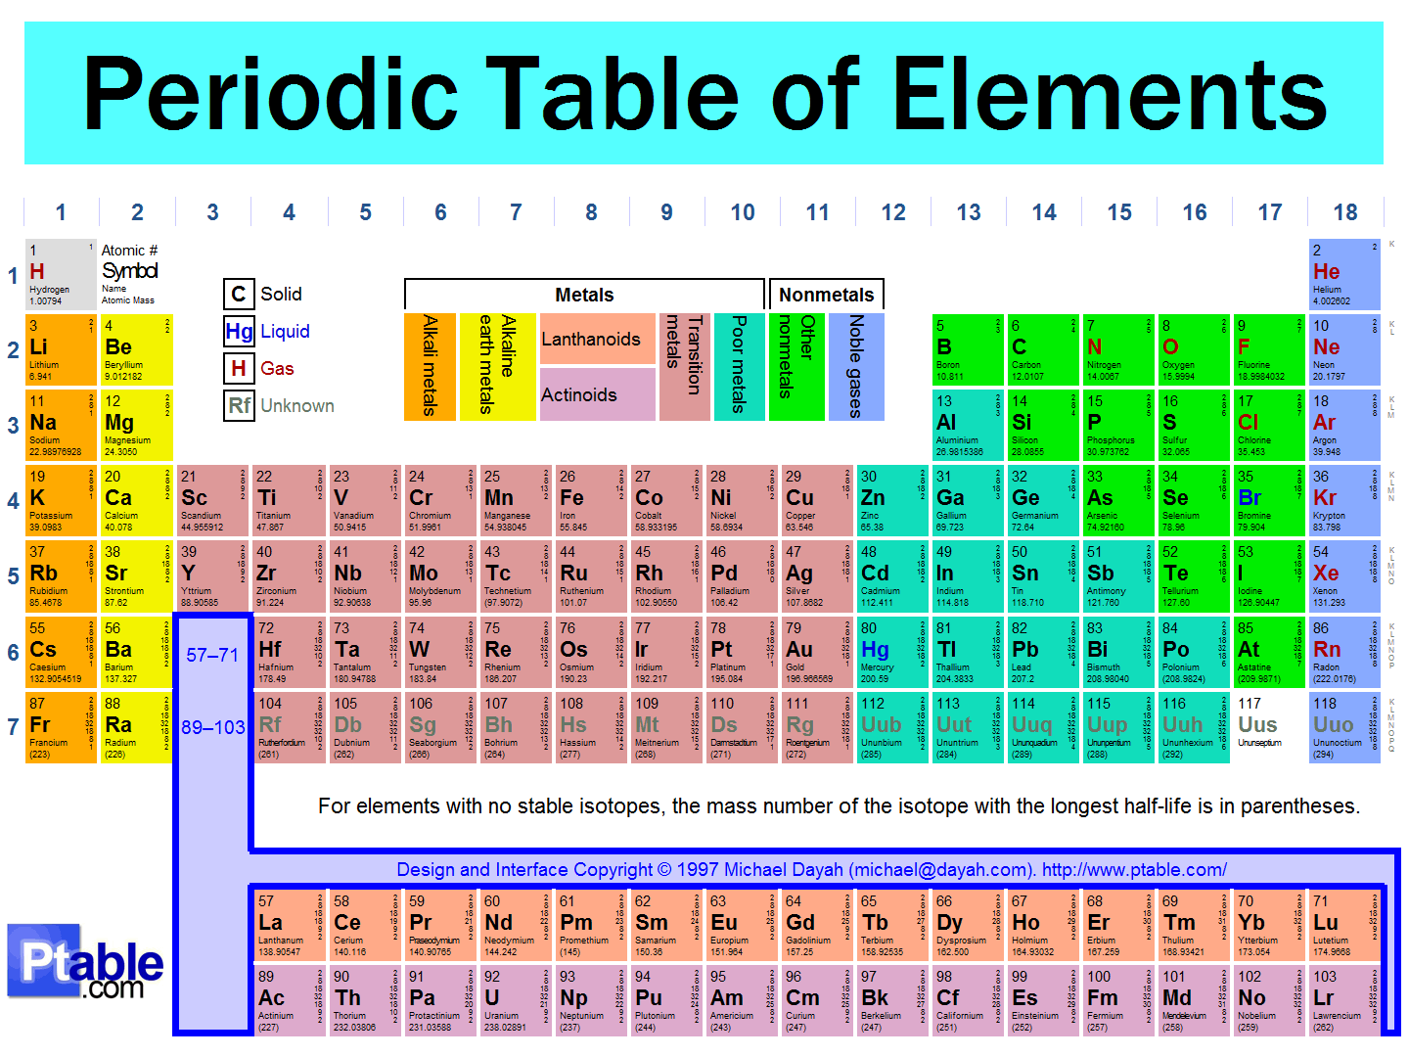

|  |  |  |  |  |  |
| --- | --- | --- | --- | --- | --- |
| **9** |  |  | **17** |  |  |
| **8** |  |  | **16** |  |  |
| **7** |  |  | **15** |  |  |
| **5** |  |  | **14** |  |  |
| **4** |  |  | **13** |  |  |
| **3** |  |  | **12** |  |  |
| **2** |  |  | **11** |  |  |
| **1** |  |  | **10** |  |  |
| **Element #** | **Electron Shells with Electrons** | **# of electrons atom needs to gain or lose** | **Element #** | **Electron Shells with Electrons** | **# of electrons atom needs to gain or lose** |