Butterfish, Penguins, and Climate Change

– Dr. Josh Kohut, March 20, 2014

**Notes**

________________________________________________________________________________________________________________________________________________________________________________________________________________________________________________________________________________________________________________________________________________________________________________________________________________________________________________________________________________________________________________________________________________________________________________________________________________________________________________________________________________________________________________________________________________

________________________________________________________________________________________________________________________________________________________________________________________________________________________________________________________________________________________________________________________________________________________________________________________________________________________________________________________________________________________________

____________________________________________________________________________________________________________________________________________________________________________________

____________________________________________________________

**Notes**

________________________________________________________________________________________________________________________________________________________________________________________________________________________________________________________________________________________________________________________________________________________________________________________________________________________________________________________________________________________________________________________________________________________________________________________________________________________________________________________________________________________________________________________________________________

________________________________________________________________________________________________________________________________________________________________________________________________________________________________________________________________________________________________________________________________________________________________________________________________________________________________________________________________________________________________

____________________________________________________________________________________________________________________________________________________________________________________

____________________________________________________________

____________________________________________________________

____________________________________________________________

If we were going to develop a model to investigate biological and physical connections in the ocean, what variables would we need to include?

*SEP 2: Developing and Using Models* - In science, models are used to represent a system (or parts of a system) under study, to aid in the development of questions and explanations, to generate data that can be used to make predictions, and to communicate ideas to others. Models are based upon evidence and when new evidence is uncovered that the models can’t explain, models are modified.

________________________________________________________________________________________________________________________________________________________________________________________________________________________________________________________________________________________________________________________________________________________________________________________________________________________________________________________________________________________________________________________________________________________________________________________________________________________________________________________________________________________________________________________________________________

________________________________________________________________________________________________________________________________________________________________________________________________________________________________________________________________________________________________________________________________________________________________________

Use evidence to construct an explanation that predicts and/or describes why fish migrate, which also includes the quantitative relationships between included variables.

*SEP 6: Constructing Explanations and Designing Solutions* - The goal of science is to construct explanations for the causes of phenomena…An explanation includes a claim that relates how a variable or variables relate to another variable or a set of variables.

________________________________________________________________________________________________________________________________________________________________________________________________________________________________________________________________________________________________________________________________________________________________________________________________________________________________________________________________________________________________________________________________________________________________________________________________________________________________________________________________________________________________________________________________________________

________________________________________________________________________________________________________________________________________________________________________________________________________________________________________________________________________________________________________________________________________________________________________

____________________________________________________________

____________________________________________________________

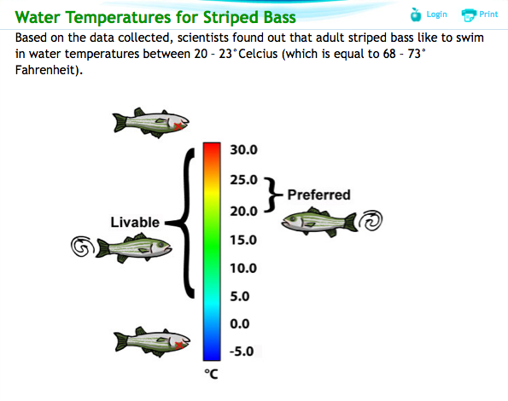

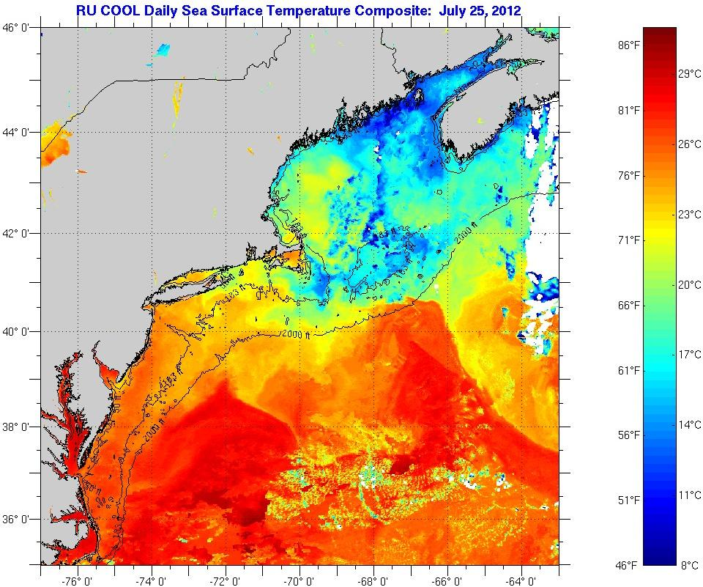

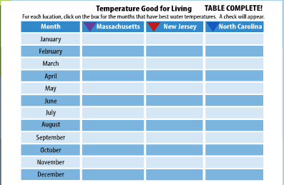

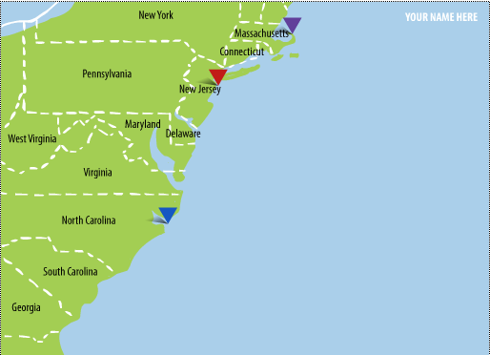

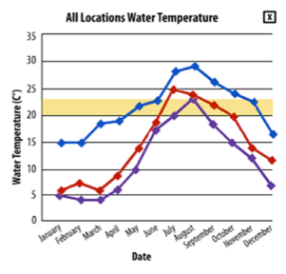

________________________________________________________________________________________________________________________________________________________________________________________________________________________________________________________________________________________________________________________________________________________________________

________________________________________________________________________________________________________________________________________________________________________________________________________________________________________________________________________________________________________________________________________________________________________

________________________________________________________________________________________________________________________

Using the data, is there a relationship between the variables? Develop a question to investigate the data further.

*SEP 1: Asking Questions and Defining Problems -* Scientific questions are distinguished from other types of questions in that the answers lie in explanations supported by empirical evidence, including evidence gathered by others or through investigation. Asking questions also involves asking questions about data, claims that are made, and proposed designs.

________________________________________________________________________________________________________________________________________________________________________________________________________________________________________________________________________________________________________________________________________________________________________________________________________________________________________________________________________________________________________________________________________________________________________________________________________________________________________________________________________________________________________________________________________________

________________________________________________________________________________________________________________________________________________________________________________________________________________________________________________________________________________________________________________________________________________________________________________________________________________________________________________________________________________________________

Use the maps to identify temporal and spatial relationships in phytoplankton along the Western Antarctic Peninsula.

*SEP 4: Analyzing and Interpreting Data* - Students are expected to interpret data by identifying significant features and patterns, use mathematics to represent relationships between variables, and take into account sources of error. It is important students present data as evidence to support their conclusions.

________________________________________________________________________________________________________________________________________________________________________________________________________________________________________________________________________________________________________________________________________________________________________________________________________________________________________________________________________________________________________________________________________________________________________________________________________________________________________________________________________________________________________________________________________________

________________________________________________________________________________________________________________________________________________________________________________________________________________________________________________________________________________________________________________________________________________________________________________________________________________________________________________________________________________________________

____________________________________________________________

Remote Sensing (Decadal Changes) – Montes-Hugo et al. 2009

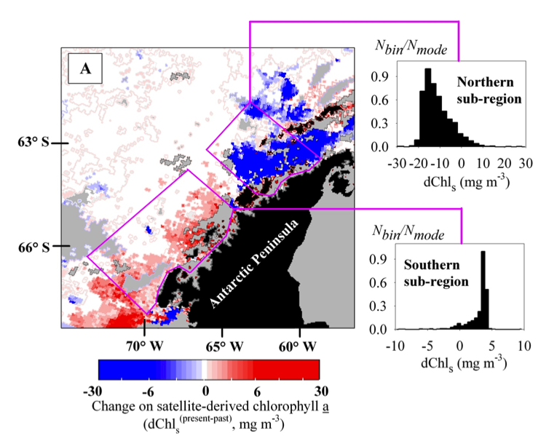

Ship Observations (Decadal Changes) – Vemet et al. 2008

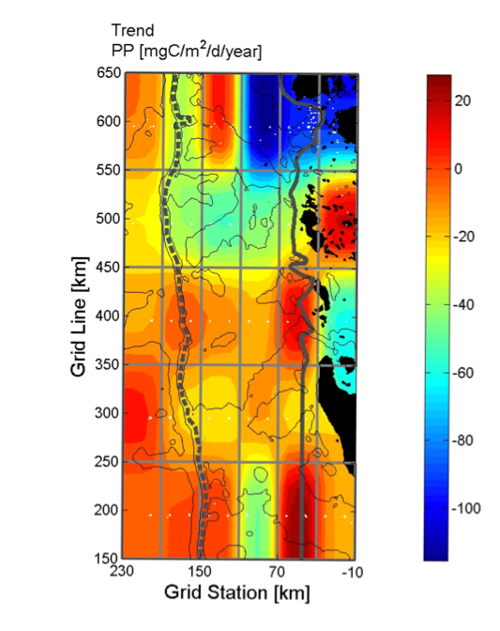

Collect data through the simulation to serve as the basis for evidence to answer the question: what effects where predators forage?

*SEP 3: Planning and Carrying Out Investigations* - Scientific investigations may be undertaken to describe a phenomenon, or to test a theory or model for how the world works.

________________________________________________________________________________________________________________________________________________________________________________________________________________________________________________________________________________________________________________________________________________________________________________________________________________________________________________________________________________________________________________________________________________________________________________________________________________________________________________________________________________________________________________________________________________

________________________________________________________________________________________________________________________________________________________________________________________________________________________________________________________________________________________________________________________________________________________________________________________________________________________________________________________________________________________________

____________________________________________________________

|  |  |  |
| --- | --- | --- |
|  | **Red Markers** | **White Markers** |
| **Round 1** |  |  |
| **Round 2** |  |  |

